**GIT & GITHUB**

SECTION 0: Installing GIT, Performing basic git commands.

1. **Create a directory project dir' & cd**

DURGA@DESKTOP-7037NSF MINGW64 ~

$ git status

fatal: not a git repository (or any of the parent directories): .git

DURGA@DESKTOP-7037NSF MINGW64 ~

$ cd Desktop

DURGA@DESKTOP-7037NSF MINGW64 ~/Desktop

$ mkdir project_dir

DURGA@DESKTOP-7037NSF MINGW64 ~/Desktop

$ cd project_dir

1. **Initialize git version database. (git init)**

DURGA@DESKTOP-7037NSF MINGW64 ~/Desktop/project_dir

$ git init

Initialized empty Git repository in C:/Users/DURGA/Desktop/project_dir/.git/

1. **Create a new file index.html.to project dir**

DURGA@DESKTOP-7037NSF MINGW64 ~/Desktop/project_dir (master)

$ touch index.html

1. **Check the git status. You should find index.html as untracked file.**

DURGA@DESKTOP-7037NSF MINGW64 ~/Desktop/project_dir (master)

$ git status

On branch master

No commits yet

Untracked files:

(use "git add <file>..." to include in what will be committed)

index.html

nothing added to commit but untracked files present (use "git add" to track)

**5. Stage the index.html file.**

DURGA@DESKTOP-7037NSF MINGW64 ~/Desktop/project_dir (master)

$ git add index.html

**6 Commit index.html**

DURGA@DESKTOP-7037NSF MINGW64 ~/Desktop/project_dir (master)

$ git commit -m 'added index.html'

[master (root-commit) 20632d6] added index.html

1 file changed, 9 insertions(+)

create mode 100644 index.html

DURGA@DESKTOP-7037NSF MINGW64 ~/Desktop/project_dir (master)

$ git status

On branch master

nothing to commit, working tree clean

1. **Make few changes in index.html & create a new file info.txt file.**
2. **Check git status. You should find index.html & info.txt as untracked files.**

DURGA@DESKTOP-7037NSF MINGW64 ~/Desktop/project_dir (master)

$ git status

On branch master

Untracked files:

(use "git add <file>..." to include in what will be committed)

index.html

info.txt

no changes added to commit (use "git add" and/or "git commit -a")

**9. Configure GIT to ignore all txt files.**

DURGA@DESKTOP-7037NSF MINGW64 ~/Desktop/project_dir (master)

$ touch .gitignore

DURGA@DESKTOP-7037NSF MINGW64 ~/Desktop/project_dir (master)

$ git add .

DURGA@DESKTOP-7037NSF MINGW64 ~/Desktop/project_dir (master)

$ git status

On branch master

Changes to be committed:

(use "git restore --staged <file>..." to unstage)

new file: .gitignore

modified: index.html

DURGA@DESKTOP-7037NSF MINGW64 ~/Desktop/project_dir (master)

$ git commit -m 'added gitignore'

[master 5725813] added gitignore

3 files changed, 3 insertions(+), 2 deletions(-)

create mode 100644 .gitignore

DURGA@DESKTOP-7037NSF MINGW64 ~/Desktop/project_dir (master)

$ git status

On branch master

nothing to commit, working tree clean

**10. Again check the git status. You should find only index.html as untracked file**

DURGA@DESKTOP-7037NSF MINGW64 ~/Desktop/project_dir (master)

$ git status

On branch master

Untracked files:

(use "git add <file>..." to include in what will be committed)

index.html

no changes added to commit (use "git add" and/or "git commit -a")

1. **State & commit index.html**

DURGA@DESKTOP-7037NSF MINGW64 ~/Desktop/project_dir (master)

$ git add .

DURGA@DESKTOP-7037NSF MINGW64 ~/Desktop/project_dir (master)

$ git status

On branch master

Changes to be committed:

(use "git restore --staged <file>..." to unstage)

modified: .gitignore

modified: index.html

DURGA@DESKTOP-7037NSF MINGW64 ~/Desktop/project_dir (master)

$ git commit -m 'updated index.html'

[master 58ee10b] updated index.html

3 files changed, 3 insertions(+), 2 deletions(-)

DURGA@DESKTOP-7037NSF MINGW64 ~/Desktop/project_dir (master)

$ git status

On branch master

nothing to commit, working tree clean

**12 Log all your comments so far**

DURGA@DESKTOP-7037NSF MINGW64 ~/Desktop/project_dir (master)

$ git log

commit 58ee10b845f12593c6f2c34dcbf856cf394c36dd (HEAD -> master)

Author: Your Name <you@example.com>

Date: Sat May 15 20:39:20 2021 +0530

updated index.html

commit 57258130efec33ced97d8d3014e91aab8585f72d

Author: Your Name <you@example.com>

Date: Sat May 15 20:32:59 2021 +0530

added gitignore

commit 20632d69c63e91b15612beff63a4af30dfe020ff

Author: Your Name <you@example.com>

Date: Sat May 15 20:22:49 2021 +0530

added index.html

**13. Make some changes in index.html**.

DURGA@DESKTOP-7037NSF MINGW64 ~/Desktop/project_dir (master)

$ git status

On branch master

Changes not staged for commit:

(use "git add <file>..." to update what will be committed)

(use "git restore <file>..." to discard changes in working directory)

modified: index.html

no changes added to commit (use "git add" and/or "git commit -a")

**14. Revert the change made in the previous step using git command.**

DURGA@DESKTOP-7037NSF MINGW64 ~/Desktop/project_dir (master)

$ git restore index.html

DURGA@DESKTOP-7037NSF MINGW64 ~/Desktop/project_dir (master)

$ git status

On branch master

nothing to commit, working tree clean

1. **Again change index.html.**
2. **Stage index.html**

DURGA@DESKTOP-7037NSF MINGW64 ~/Desktop/project_dir (master)

$ git add .

DURGA@DESKTOP-7037NSF MINGW64 ~/Desktop/project_dir (master)

$ git status

On branch master

Changes to be committed:

(use "git restore --staged <file>..." to unstage)

modified: index.html

**17. Revert back the last stage**.

DURGA@DESKTOP-7037NSF MINGW64 ~/Desktop/project_dir (master)

$ git restore --staged index.html

**18. Rename 'add' command to 'my-add'.**

DURGA@DESKTOP-7037NSF MINGW64 ~/Desktop/project_dir (master)

$ alias my_add="git add"

**19. Using my add command Stage index.html again & commit the changes.**

DURGA@DESKTOP-7037NSF MINGW64 ~/Desktop/project_dir (master)

$ my_add index.html

DURGA@DESKTOP-7037NSF MINGW64 ~/Desktop/project_dir (master)

$ git status

On branch master

Changes to be committed:

(use "git restore --staged <file>..." to unstage)

modified: index.html

DURGA@DESKTOP-7037NSF MINGW64 ~/Desktop/project_dir (master)

$ git commit -m 'updated index.html'

[master 3a4172c] updated index.html

1 file changed, 1 insertion(+)

DURGA@DESKTOP-7037NSF MINGW64 ~/Desktop/project_dir (master)

$ git status

On branch master

nothing to commit, working tree clean

**20. Revert the last commit.**

DURGA@DESKTOP-7037NSF MINGW64 ~/Desktop/project_dir (master)

$ git revert 3a417

[master ebf1de8] Revert "updated index.html"

1 file changed, 1 deletion(-)

DURGA@DESKTOP-7037NSF MINGW64 ~/Desktop/project_dir (master)

$ git status

On branch master

nothing to commit, working tree clean

GIT Branching

SECTION 1: Creating branch and adding HTML assignments.

1. **First take a backup of your assignments & projects. This is required because due incorrect GIT operation you may lose your files.**

**22. Create an empty directory 'Assignments' & cd to 'Assignments**

DURGA@DESKTOP-7037NSF MINGW64 ~

$ cd Desktop

DURGA@DESKTOP-7037NSF MINGW64 ~/Desktop

$ mkdir Assignments

DURGA@DESKTOP-7037NSF MINGW64 ~/Desktop

$ cd Assignments

**23. Create a file README.txt inside 'Assignments' & write few lines about the content**

**Assignments folder.**

DURGA@DESKTOP-7037NSF MINGW64 ~/Desktop/Assignments

$ touch README.txt

DURGA@DESKTOP-7037NSF MINGW64 ~/Desktop/Assignments

$ git init

Initialized empty Git repository in C:/Users/DURGA/Desktop/Assignments/.git/

**24. Commit README.txt file.**

DURGA@DESKTOP-7037NSF MINGW64 ~/Desktop/Assignments (master)

$ git add .

DURGA@DESKTOP-7037NSF MINGW64 ~/Desktop/Assignments (master)

$ git commit -m 'Added README.txt'

[master (root-commit) 2fab9e3] Added README.txt

1 file changed, 4 insertions(+)

create mode 100644 README.txt

DURGA@DESKTOP-7037NSF MINGW64 ~/Desktop/Assignments (master)

$ git status

On branch master

nothing to commit, working tree clean

**25. Now create a new branch "html-assignments**

DURGA@DESKTOP-7037NSF MINGW64 ~/Desktop/Assignments (master)

$ git branch html-assignment

DURGA@DESKTOP-7037NSF MINGW64 ~/Desktop/Assignments (master)

$ git status

On branch master

nothing to commit, working tree clean

**26 Switch to html assignments branch.**

DURGA@DESKTOP-7037NSF MINGW64 ~/Desktop/Assignments (master)

$ git checkout html-assignment

Switched to branch 'html-assignment'

**27 Copy all HTML assignments inside Assignments folder**

DURGA@DESKTOP-7037NSF MINGW64 ~/Desktop/Assignments (html-assignment)

$ touch index.html

**28. Commit HTML assignments into 'html-assignments' branch.**

DURGA@DESKTOP-7037NSF MINGW64 ~/Desktop/Assignments (html-assignment)

$ git add index.html

DURGA@DESKTOP-7037NSF MINGW64 ~/Desktop/Assignments (html-assignment)

$ git commit -m 'html assignments added.'

[html-assignment 603b553] html assignments added.

1 file changed, 36 insertions(+)

create mode 100644 index.html

**29. Make minor changes into few files belonging to 'html-assignments' branch.**

DURGA@DESKTOP-7037NSF MINGW64 ~/Desktop/Assignments (html-assignment)

$ git status

On branch html-assignment

Changes not staged for commit:

(use "git add <file>..." to update what will be committed)

(use "git restore <file>..." to discard changes in working directory)

modified: index.html

no changes added to commit (use "git add" and/or "git commit -a")

**30. Commit those changed files.**

DURGA@DESKTOP-7037NSF MINGW64 ~/Desktop/Assignments (html-assignment)

$ git add .

DURGA@DESKTOP-7037NSF MINGW64 ~/Desktop/Assignments (html-assignment)

$ git commit -m 'html assignments updated.'

[html-assignment 3c96ce5] html assignments updated.

1 file changed, 17 insertions(+), 36 deletions(-)

rewrite index.html (71%)

**31. Switch to master branch.**

DURGA@DESKTOP-7037NSF MINGW64 ~/Desktop/Assignments (html-assignment)

$ git checkout master

Switched to branch 'master'

**32. Make minor changes into README.txt file & commit those changes into master.**

DURGA@DESKTOP-7037NSF MINGW64 ~/Desktop/Assignments (master)

$ git status

On branch master

Changes not staged for commit:

(use "git add <file>..." to update what will be committed)

(use "git restore <file>..." to discard changes in working directory)

modified: README.txt

no changes added to commit (use "git add" and/or "git commit -a")

DURGA@DESKTOP-7037NSF MINGW64 ~/Desktop/Assignments (master)

$ git add .

DURGA@DESKTOP-7037NSF MINGW64 ~/Desktop/Assignments (master)

$ git commit -m 'README.txt updated.'

[master 5d305d7] README.txt updated.

1 file changed, 3 insertions(+), 1 deletion(-)

**33. Again switch to html assignments branch.**

DURGA@DESKTOP-7037NSF MINGW64 ~/Desktop/Assignments (master)

$ git checkout html-assignment

Switched to branch 'html-assignment'

**34. Make minor changes into few files belonging to html assignments branch.**

DURGA@DESKTOP-7037NSF MINGW64 ~/Desktop/Assignments (html-assignment)

$ git status

On branch html-assignment

Changes not staged for commit:

(use "git add <file>..." to update what will be committed)

(use "git restore <file>..." to discard changes in working directory)

modified: index.html

no changes added to commit (use "git add" and/or "git commit -a")

**35. Commit those changes.**

DURGA@DESKTOP-7037NSF MINGW64 ~/Desktop/Assignments (html-assignment)

$ git add .

DURGA@DESKTOP-7037NSF MINGW64 ~/Desktop/Assignments (html-assignment)

$ git commit -m 'html assignments updated.'

[html-assignment 4616fd9] html assignments updated.

1 file changed, 1 insertion(+)

**36. Switch to master.**

DURGA@DESKTOP-7037NSF MINGW64 ~/Desktop/Assignments (html-assignment)

$ git checkout master

Switched to branch 'master'

**37 Merge html-assignments branch into master. Confirm all html assignments are shown in master**

DURGA@DESKTOP-7037NSF MINGW64 ~/Desktop/Assignments (master)

$ git merge html-assignment

Merge made by the 'recursive' strategy.

index.html | 18 ++++++++++++++++++

1 file changed, 18 insertions(+)

create mode 100644 index.html

DURGA@DESKTOP-7037NSF MINGW64 ~/Desktop/Assignments (master)

$ git branch --merged master

html-assignment

* master

**38. Finally delete the html assignments branch.**

DURGA@DESKTOP-7037NSF MINGW64 ~/Desktop/Assignments (master)

$ git branch -d html-assignment

Deleted branch html-assignment (was 4616fd9).

DURGA@DESKTOP-7037NSF MINGW64 ~/Desktop/Assignments (master)

$ git branch

* master

SECTION 2: Creating branch and adding CSS assignments.

**1. Create a new branch 'css-assignments'.**

DURGA@DESKTOP-7037NSF MINGW64 ~/Desktop/Assignments (master)

$ git branch css-assignment

DURGA@DESKTOP-7037NSF MINGW64 ~/Desktop/Assignments (master)

$ git status

On branch master

nothing to commit, working tree clean

**2. Switch to 'css-assignments' branch.**

DURGA@DESKTOP-7037NSF MINGW64 ~/Desktop/Assignments (master)

$ git checkout css-assignment

Switched to branch css-assignment'

**3. Copy all CSS assignments inside 'Assignments' folder.**

DURGA@DESKTOP-7037NSF MINGW64 ~/Desktop/Assignments (css-assignment)

$ touch styles.css

**4. Commit CSS assignments into 'css-assignments' branch.**

DURGA@DESKTOP-7037NSF MINGW64 ~/Desktop/Assignments (css-assignment)

$ git add styles.css

DURGA@DESKTOP-7037NSF MINGW64 ~/Desktop/Assignments (css-assignment)

$ git commit -m css assignments added.'

[css-assignment 603b553] css assignments added.

1 file changed, 36 insertions(+)

create mode 100644 styles.css

**5. Make minor changes into file on line 1 belonging to 'ess-assignments'**

**branch.**

DURGA@DESKTOP-7037NSF MINGW64 ~/Desktop/Assignments (css-assignment)

$ git status

On branch css-assignment

Changes not staged for commit:

(use "git add <file>..." to update what will be committed)

(use "git restore <file>..." to discard changes in working directory)

modified: styles.css

no changes added to commit (use "git add" and/or "git commit -a")

**6. Commit those changed files.**

DURGA@DESKTOP-7037NSF MINGW64 ~/Desktop/Assignments (css-assignment)

$ git add .

DURGA@DESKTOP-7037NSF MINGW64 ~/Desktop/Assignments (css-assignment)

$ git commit -m css assignments updated.'

[css-assignment 3c96ce5] css assignments updated.

1 file changed, 17 insertions(+), 36 deletions(-)

rewrite styles.css (71%)

**7. Switch to master branch.**

DURGA@DESKTOP-7037NSF MINGW64 ~/Desktop/Assignments (css-assignment)

$ git checkout master

Switched to branch 'master'

**8. Make minor changes into README.txt file on line 3 & commit those changes into master.**

DURGA@DESKTOP-7037NSF MINGW64 ~/Desktop/Assignments (master)

$ git status

On branch master

Changes not staged for commit:

(use "git add <file>..." to update what will be committed)

(use "git restore <file>..." to discard changes in working directory)

modified: README.txt

no changes added to commit (use "git add" and/or "git commit -a")

DURGA@DESKTOP-7037NSF MINGW64 ~/Desktop/Assignments (master)

$ git add .

DURGA@DESKTOP-7037NSF MINGW64 ~/Desktop/Assignments (master)

$ git commit -m 'README.txt updated.'

[master 5d305d7] README.txt updated.

1 file changed, 3 insertions(+), 1 deletion(-)

**9. Again switch to 'css-assignments' branch.**

DURGA@DESKTOP-7037NSF MINGW64 ~/Desktop/Assignments (master)

$ git checkout css-assignment

Switched to branch css-assignment'

**10. Make minor changes into few files belonging to 'css-assignments' branch.**

DURGA@DESKTOP-7037NSF MINGW64 ~/Desktop/Assignments (css-assignment)

$ git status

On branch css-assignment

Changes not staged for commit:

(use "git add <file>..." to update what will be committed)

(use "git restore <file>..." to discard changes in working directory)

modified: styles.css

no changes added to commit (use "git add" and/or "git commit -a")

**11. Commit those changes.**

DURGA@DESKTOP-7037NSF MINGW64 ~/Desktop/Assignments (css-assignment)

$ git add .

DURGA@DESKTOP-7037NSF MINGW64 ~/Desktop/Assignments (css-assignment)

$ git commit -m css assignments updated.'

[css-assignment 4616fd9] css assignments updated.

1 file changed, 1 insertion(+)

**12. Switch to master.**

DURGA@DESKTOP-7037NSF MINGW64 ~/Desktop/Assignments (css-assignment)

$ git checkout master

Switched to branch 'master'

**13. Merge 'css-assignments' branch into master. Confirm all css assignments are shown in master.**

DURGA@DESKTOP-7037NSF MINGW64 ~/Desktop/Assignments (master)

$ git merge css-assignment

Merge made by the 'recursive' strategy.

styles.css | 18 ++++++++++++++++++

1 file changed, 18 insertions(+)

create mode 100644 styles.css

DURGA@DESKTOP-7037NSF MINGW64 ~/Desktop/Assignments (master)

$ git branch --merged master

css-assignment

* master

**14. Finally delete the 'css-assignments branch.**

DURGA@DESKTOP-7037NSF MINGW64 ~/Desktop/Assignments (master)

$ git branch -d css-assignment

Deleted branch css-assignment (was 4616fd9).

DURGA@DESKTOP-7037NSF MINGW64 ~/Desktop/Assignments (master)

$ git branch

* master

SECTION 3: Creating branch and adding Javascript assignments.

1. **Create a new branch is assignments.**

DURGA@DESKTOP-7037NSF MINGW64 ~/Desktop/Assignments (master)

$ git branch js-assignment

DURGA@DESKTOP-7037NSF MINGW64 ~/Desktop/Assignments (master)

$ git status

On branch master

nothing to commit, working tree clean

**2. Switch to js assignments' branch:**

DURGA@DESKTOP-7037NSF MINGW64 ~/Desktop/Assignments (master)

$ git checkout js-assignment

Switched to branch js-assignment'

**3. Copy all JavaScript assignments inside Assignments folder**

DURGA@DESKTOP-7037NSF MINGW64 ~/Desktop/Assignments (js-assignment)

$ touch index.js

**4 Commit JavaScript assignments into js-assignments branch.**

DURGA@DESKTOP-7037NSF MINGW64 ~/Desktop/Assignments (js-assignment)

$ git add index.js

DURGA@DESKTOP-7037NSF MINGW64 ~/Desktop/Assignments (js-assignment)

$ git commit -m js assignments added.'

[js-assignment 603b553] js assignments added.

1 file changed, 36 insertions(+)

create mode 100644 index.js

**5. Make minor changes into README.txt file on line 1 belonging to is assignments branch**

DURGA@DESKTOP-7037NSF MINGW64 ~/Desktop/Assignments (js-assignment)

$ git status

On branch js-assignment

Changes not staged for commit:

(use "git add <file>..." to update what will be committed)

(use "git restore <file>..." to discard changes in working directory)

modified: index.js

no changes added to commit (use "git add" and/or "git commit -a")

**6 Commit those changed files**

DURGA@DESKTOP-7037NSF MINGW64 ~/Desktop/Assignments (js-assignment)

$ git add .

DURGA@DESKTOP-7037NSF MINGW64 ~/Desktop/Assignments (js-assignment)

$ git commit -m js assignments updated.'

[js-assignment 3c96ce5] js assignments updated.

1 file changed, 17 insertions(+), 36 deletions(-)

rewrite index.js (71%)

**7. Switch to master branch**

DURGA@DESKTOP-7037NSF MINGW64 ~/Desktop/Assignments (js-assignment)

$ git checkout master

Switched to branch 'master'

**8. Make minor changes into README.txt file on line 1 & commit those changes into master.**

DURGA@DESKTOP-7037NSF MINGW64 ~/Desktop/Assignments (master)

$ git status

On branch master

Changes not staged for commit:

(use "git add <file>..." to update what will be committed)

(use "git restore <file>..." to discard changes in working directory)

modified: README.txt

no changes added to commit (use "git add" and/or "git commit -a")

DURGA@DESKTOP-7037NSF MINGW64 ~/Desktop/Assignments (master)

$ git add .

DURGA@DESKTOP-7037NSF MINGW64 ~/Desktop/Assignments (master)

$ git commit -m 'README.txt updated.'

[master 5d305d7] README.txt updated.

1 file changed, 3 insertions(+), 1 deletion(-)

**9. Again switch to js-assignments' branch.**

DURGA@DESKTOP-7037NSF MINGW64 ~/Desktop/Assignments (master)

$ git checkout js-assignment

Switched to branch js-assignment'

**10. Make minor changes into few files belonging to 'js-assignments' branch.**

DURGA@DESKTOP-7037NSF MINGW64 ~/Desktop/Assignments (js-assignment)

$ git status

On branch js-assignment

Changes not staged for commit:

(use "git add <file>..." to update what will be committed)

(use "git restore <file>..." to discard changes in working directory)

modified: index.js

no changes added to commit (use "git add" and/or "git commit -a")

**11. Commit those changes.**

DURGA@DESKTOP-7037NSF MINGW64 ~/Desktop/Assignments (js-assignment)

$ git add .

DURGA@DESKTOP-7037NSF MINGW64 ~/Desktop/Assignments (js-assignment)

$ git commit -m js assignments updated.'

[js-assignment 4616fd9] js assignments updated.

1 file changed, 1 insertion(+)

**12. Switch to master.**

DURGA@DESKTOP-7037NSF MINGW64 ~/Desktop/Assignments (js-assignment)

$ git checkout master

Switched to branch 'master'

**13. Merge js-assignments branch into master. Confirm all JavaScript assignments are shown in master..**

DURGA@DESKTOP-7037NSF MINGW64 ~/Desktop/Assignments (master)

$ git merge js-assignment

Merge made by the 'recursive' strategy.

index.js | 18 ++++++++++++++++++

1 file changed, 18 insertions(+)

create mode 100644 index.js

DURGA@DESKTOP-7037NSF MINGW64 ~/Desktop/Assignments (master)

$ git branch --merged master

js-assignment

* master

**14. Finally delete the js-assignments' branch.**

DURGA@DESKTOP-7037NSF MINGW64 ~/Desktop/Assignments (master)

$ git branch -d js-assignment

Deleted branch js-assignment (was 4616fd9).

DURGA@DESKTOP-7037NSF MINGW64 ~/Desktop/Assignments (master)

$ git branch

* master

GIT Remoting

Objective: Pushing source code into GITHUB & collaborate team members,

1. **Create a github account if you do not have already.**

**40. Login on into github account**

<https://github.com/>

1. **Create new public repository ‘freshersbatch oct 16’**

DURGA@DESKTOP-7037NSF MINGW64 ~/Desktop/Assignments (master)

$ git remote

**42. Commit & push any sample file to this repasitory under "Assignments directory**.

DURGA@DESKTOP-7037NSF MINGW64 ~/Desktop/Assignments (master)

$ git remote add origin https://github.com/adarsht88/freshersbatch-oct16.git

DURGA@DESKTOP-7037NSF MINGW64 ~/Desktop/Assignments (master)

$ git remote

origin

DURGA@DESKTOP-7037NSF MINGW64 ~/Desktop/Assignments (master)

$ git push origin master

Enumerating objects: 17, done.

Counting objects: 100% (17/17), done.

Delta compression using up to 4 threads

Compressing objects: 100% (15/15), done.

Writing objects: 100% (17/17), 2.02 KiB | 73.00 KiB/s, done.

Total 17 (delta 2), reused 0 (delta 0), pack-reused 0

remote: Resolving deltas: 100% (2/2), done.

To https://github.com/adarsht88/freshersbatch-oct16.git

* [new branch] master -> master

SECTION 4: Pushing code to remote repository using eclipse git plugin.

**1: One developer from project team will create eclipse projects SamplePro & add sample source code files. Then commit all files through eclipse GIT plugin**

Step 1 : Start Eclipse.

Step 2 : Goto Perspective -> Git Repositories and click on Add Git repository

Step 3 : fill the URL of your repository.

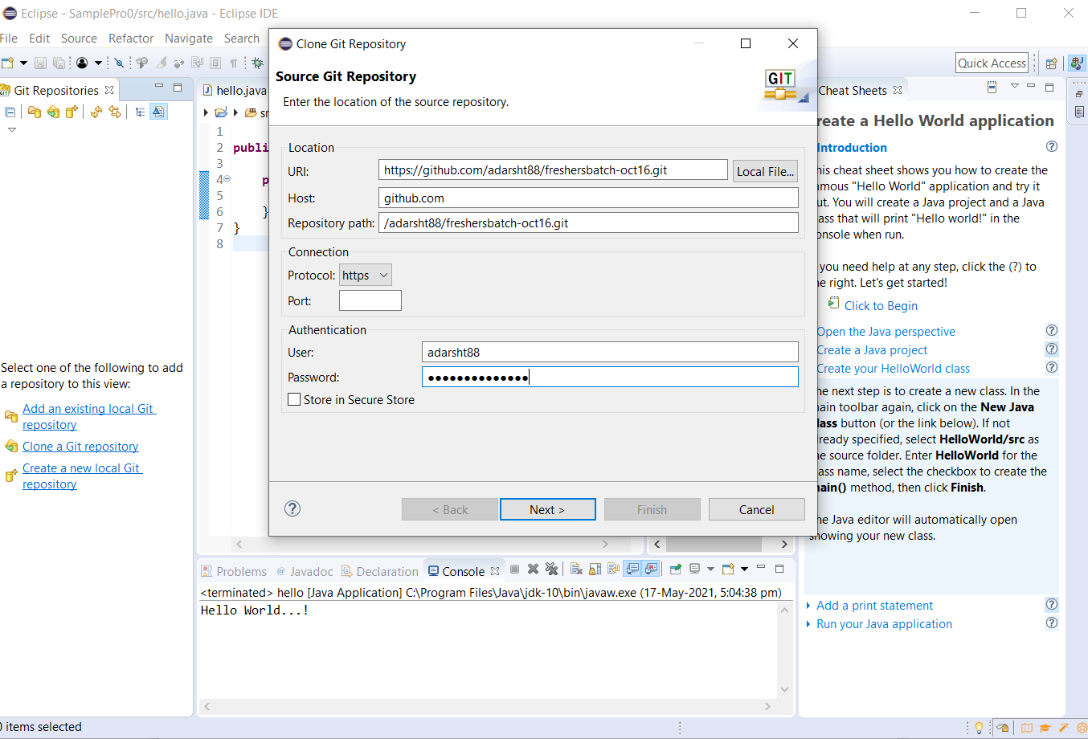

Step 5 : Create a project in Eclipse

Step 6 : Do a right click on Project -> Team -> Share -> Add the git repository

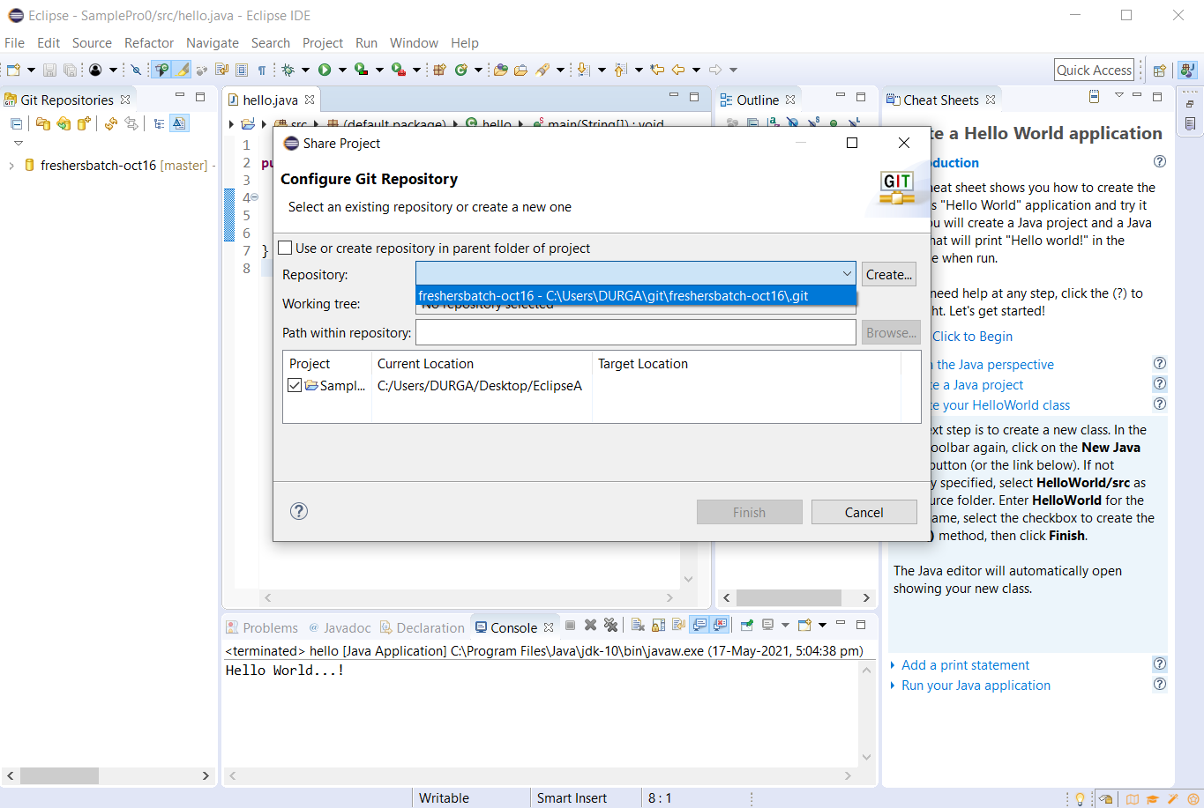

Step 7 : Commit and Push the project to the repository

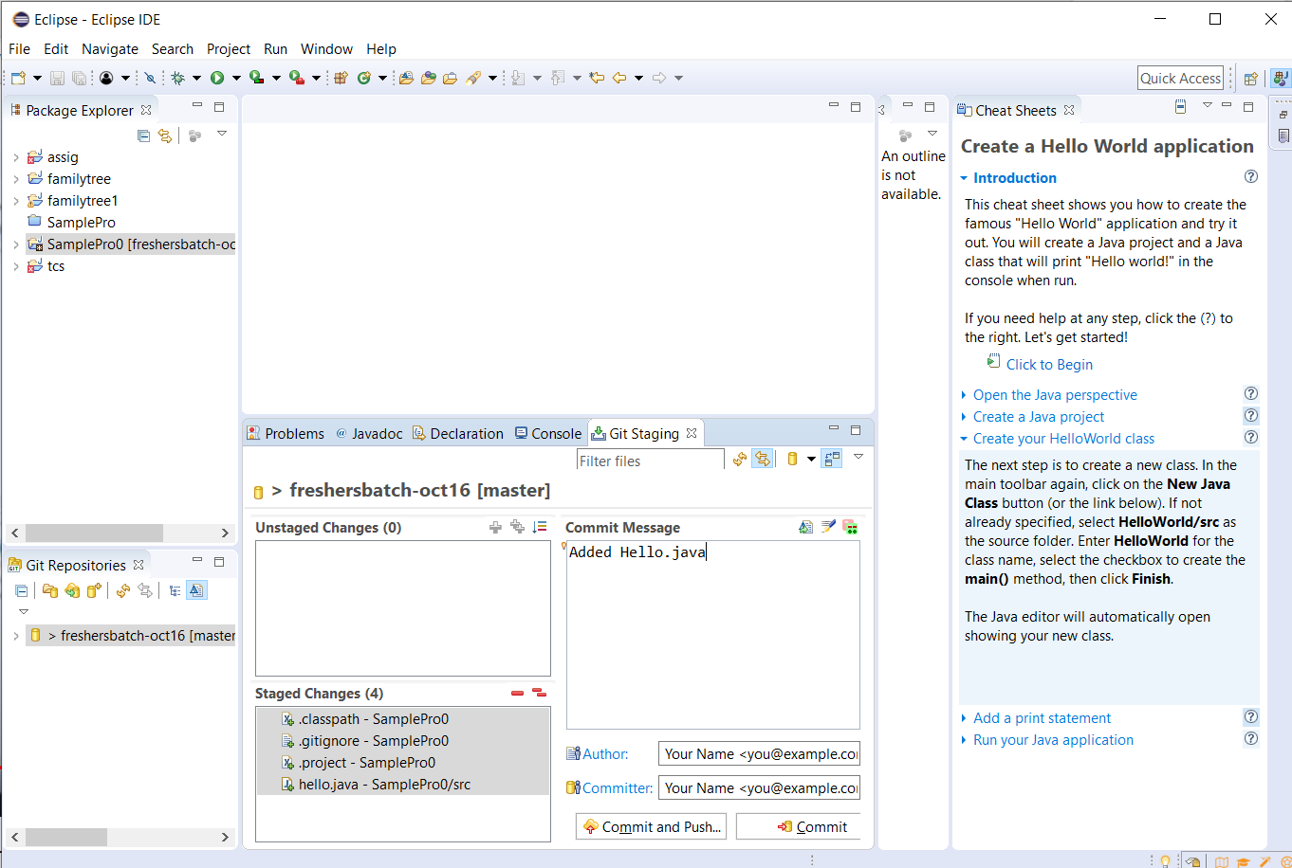

1. **Other developers from same team will checkout all files from remote repository. This might get conflicts since certain files fail to merge. In such case, merge it manually.**

**3. Commit & push the SampleProj' project**

**Step 1 : clone the repository from github**.

<https://github.com/adarsht88/freshersbatch-oct16.git>

**Step 2 : Create and checkout a new branch.**

DURGA@DESKTOP-7037NSF MINGW64 ~/git/freshersbatch-oct16/SamplePro0 (master)

$ git checkout -b mybranch

Switched to a new branch 'mybranch'

**Step 3 : Add or change files.**

**Step 4 : Add and commit the modified files.**

DURGA@DESKTOP-7037NSF MINGW64 ~/git/freshersbatch-oct16/SamplePro0 (mybranch)

$ git status

On branch mybranch

Changes not staged for commit:

(use "git add <file>..." to update what will be committed)

(use "git restore <file>..." to discard changes in working directory)

modified: src/hello.java

no changes added to commit (use "git add" and/or "git commit -a")

DURGA@DESKTOP-7037NSF MINGW64 ~/git/freshersbatch-oct16/SamplePro0 (mybranch)

$ git add src/hello.java

DURGA@DESKTOP-7037NSF MINGW64 ~/git/freshersbatch-oct16/SamplePro0 (mybranch)

$ git commit -m 'Updated hello.java'

[mybranch 6a0811a] Updated hello.java

1 file changed, 1 insertion(+)

**Step 5 : Push your branch to github.**

DURGA@DESKTOP-7037NSF MINGW64 ~/git/freshersbatch-oct16/SamplePro0 (mybranch)

$ git push -u origin mybranch

Enumerating objects: 9, done.

Counting objects: 100% (9/9), done.

Delta compression using up to 4 threads

Compressing objects: 100% (4/4), done.

Writing objects: 100% (5/5), 473 bytes | 157.00 KiB/s, done.

Total 5 (delta 2), reused 0 (delta 0), pack-reused 0

remote: Resolving deltas: 100% (2/2), completed with 2 local objects.

remote:

remote: Create a pull request for 'mybranch' on GitHub by visiting:

remote: https://github.com/adarsht88/freshersbatch-oct16/pull/new/mybranch

remote:

To https://github.com/adarsht88/freshersbatch-oct16.git

* [new branch] mybranch -> mybranch

Branch 'mybranch' set up to track remote branch 'mybranch' from 'origin'.

**Step 6 : go to github -> find branch -> issue pull request.**

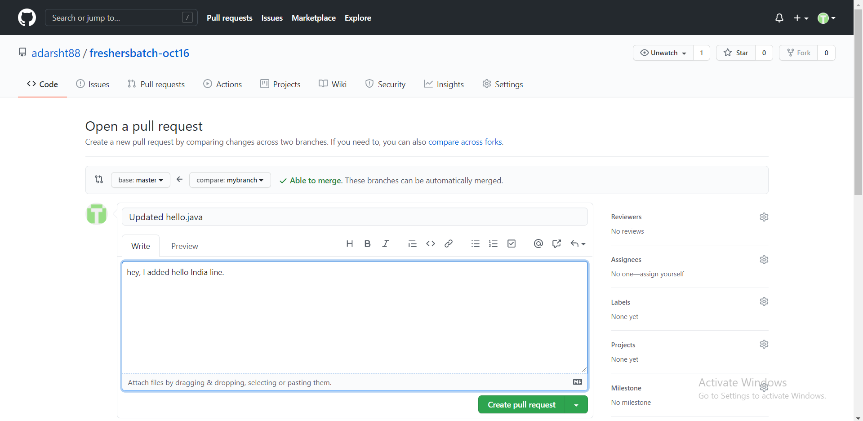

**Step 7 : review request**

**Step 8 : merge to the mainr branch**

